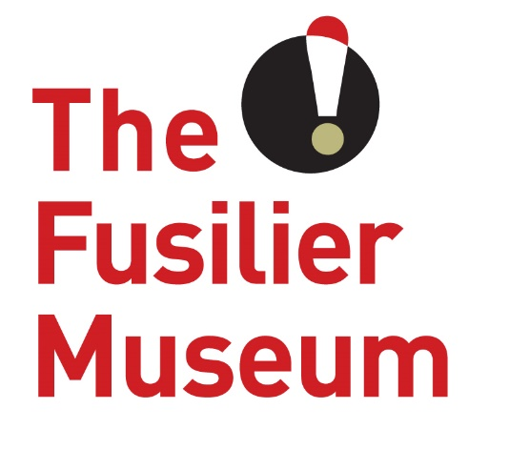

Activity Volunteer
Volunteer Role Description
The Fusilier Museum & Learning Centre Bury

What is an Activity Volunteer?
Activity volunteers at The Fusilier Museum help to deliver exciting experiences that aim to inspire curiosity, creativity and imagination in every child, young person and their families who come through our doors. This may also include school groups if this is an area of our programme you would like to be involved with. You will be part of small team creating spaces, making resources, supporting activities and helping with collecting session feedback.
What’s in it for you?
- The opportunity to gain experience delivering learning activities and working alongside children and young people
- Join an enthusiastic and varied volunteer team in a beautiful building with local and historic significance
- A sense of fulfilment knowing that you are helping to support a much-loved part of regimental history
What’s involved?
- Preparing equipment, materials, and resources for activities
- Creating suitable workspaces for table-top or floor-based activities
- Giving a clear instruction when assisting with activities
- Producing before, during and after samples – if appropriate to the activity
- Demonstrating what is going to take place and offering support to individuals or the group when needed
- Supporting any session feedback and evaluation

This role will suit people who…
- Want to gain experience working in an educational environment
- Have excellent communication skills
- Are patient with an outgoing personality
- Have the ability to work to a pre-established programme but can adapt it to suit a groups needs
- Work well in a team
- Enjoy working with children and young people, as well as adults
- Are able to pass on knowledge or skills
- Enjoy crafts and/or art
- Are willing to undergo a Disclosure and Barring check

Extra information
Time Commitment: Events based
Volunteer Manager: To be allocated – Community Development & Volunteer Coordinator
Training for the role:
- Customer care
- Working with young people and learning groups
- Safeguarding and dementia friendly training

About The Museum
The Fusilier Museum is home to the collections of the XX Lancashire Fusiliers and the Royal Regiment of Fusiliers. Together they record over 300 years of history and heritage of the people who served and continue to serve in the regiments.
As well as being an award-winning museum it is also a conference and events venue and regular location for school visits throughout the year. It also has an archive which assists people with family history enquiries about the Lancashire Fusiliers.
The museum is as much about the future as it is about the past. Building on an exploration of the past and the present, The Museum is a place for people to take part of a community. It is a place for people to share their hopes and visions of a better future, and to work together to create the community we want to live in.
The museum has a growing friendly team of volunteers who are at the very heart of everything we do. The volunteers share our passion to provide a unique, experience rich in heritage and culture. The contribution and dedication of our volunteers enables us to provide a sustainable museum that is available to everyone.

This role is purely voluntary and this arrangement is not meant to be legally binding or an employment contract.

www.fusiliermuseum.com

