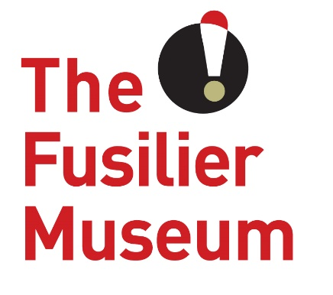
Meet & Greet Volunteer
Volunteer Role Description
The Fusilier Museum & Learning Centre Bury

What is a Meet & Greet Volunteer?
Our Meet & Greet volunteers are more than just a friendly face, from greeting every visitor with a warm and friendly smile to answering the phones, they are the heart of The Museum and represent the best of all we have to offer.
What’s in it for you?
- Enhance your social skills and grow in confidence whilst working in a popular and well-loved local venue
- Join an enthusiastic and varied volunteer team in a beautiful building with local and historic significance
- A sense of fulfilment knowing that you are helping to support a much-loved part of regimental history
What’s involved?
- Welcoming visitors on entry to the museum and ensuring they get the most out of their visit
- Taking payments for tickets and shop sales
- Helping to orientate visitors, advising of our current exhibitions, and enabling them to access other services in the museum such as shop, cafe, and the archive
- Answering enquiries from visitors, both over the phone and in person
- Basic admin – data inputting, typing, sorting mail etc
This role will suit people who…
- Enjoy working in a public environment and has outstanding customer service skills
- Are reliable, flexible and are able to help out on a regular basis
- Have the ability to work without supervision, follow guidelines and instructions
- Are interested in gaining experience of working in customer service, retail, and museums
- Have a friendly and approachable manner
- Interest in and some knowledge of the regiment or local history
Extra information
Time Commitment: 2 or 3 days a week
Volunteer Manager: To be allocated– Community Development & Volunteer Coordinator
Training for the role:
- Customer care
- Collections familiarisation
- Working with young people and learning groups
- Family friendly training
- Safeguarding and dementia friendly training

About The Museum
The Fusilier Museum is home to the collections of the XX Lancashire Fusiliers and the Royal Regiment of Fusiliers. Together they record over 300 years of history and heritage of the people who served and continue to serve in the regiments.
As well as being an award-winning museum it is also a conference and events venue and regular location for school visits throughout the year. It also has an archive which assists people with family history enquiries about the Lancashire Fusiliers.
The museum is as much about the future as it is about the past. Building on an exploration of the past and the present, The Museum is a place for people to take part of a community. It is a place for people to share their hopes and visions of a better future, and to work together to create the community we want to live in.
The museum has a growing friendly team of volunteers who are at the very heart of everything we do. The volunteers share our passion to provide a unique, experience rich in heritage and culture. The contribution and dedication of our volunteers enables us to provide a sustainable museum that is available to everyone.
This role is purely voluntary, and this arrangement is not meant to be legally binding or an employment contract.

www.fusiliermuseum.com

