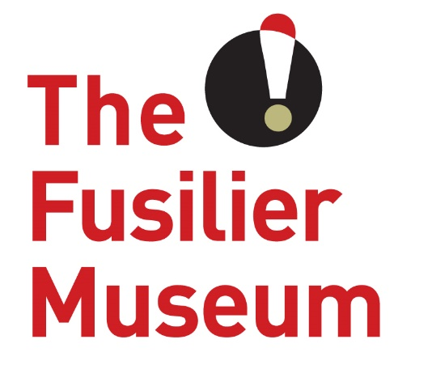

Marketing Volunteer
Volunteer Role Description
The Fusilier Museum & Learning Centre Bury

What is a Marketing Volunteer?
Marketing volunteers at The Fusilier Museum help to promote the museum to its key target audiences throughout the year. The role involves supporting the freelance Marketing Manager to deliver core activity across all parts of the business including developing the website and growing our social media as well as digital presence.
What’s in it for you?
- The opportunity to gain hands-on marketing experience
- Join an enthusiastic and varied volunteer team in a beautiful building with local and historic significance
- A sense of fulfilment knowing that you are helping to support a much-loved part of regimental history
What’s involved?
- Updating the website with event/ exhibition content as well as news and any other changes required
- Working with our external web company to ensure the site is top of the list in google rankings and other searches
- Scheduling and posting content on all social media platforms
- Growing our audiences on social media platforms
- Photographing items from the shop – uploading onto our new online shop and working with our shop manager to maximise sales

This role will suit people who…
- Want to gain experience working in a digital marketing environment
- Have excellent communication skills
- Are patient with an outgoing personality
- Have the ability to work on their own under guidance and follow instructions
- Work well in a team
- Enjoy working with children and young people, as well as adults
- Are willing to undergo a Disclosure and Barring check
Extra information
Time Commitment: Negotiable
Volunteer Manager: To be allocated – Community Development & Volunteer Coordinator
Training for the role:
- Customer care
- Working with young people and learning groups
- Safeguarding and dementia friendly training
About The Museum
The Fusilier Museum is home to the collections of the XX Lancashire Fusiliers and the Royal Regiment of Fusiliers. Together they record over 300 years of history and heritage of the people who served and continue to serve in the regiments.
As well as being an award-winning museum it is also a conference and events venue and regular location for school visits throughout the year. It also has an archive which assists people with family history enquiries about the Lancashire Fusiliers.
The museum is as much about the future as it is about the past. Building on an exploration of the past and the present, The Museum is a place for people to take part of a community. It is a place for people to share their hopes and visions of a better future, and to work together to create the community we want to live in.
The museum has a growing friendly team of volunteers who are at the very heart of everything we do. The volunteers share our passion to provide a unique, experience rich in heritage and culture. The contribution and dedication of our volunteers enables us to provide a sustainable museum that is available to everyone.
This role is purely voluntary, and this arrangement is not meant to be legally binding or an employment contract.

www.fusiliermuseum.com

