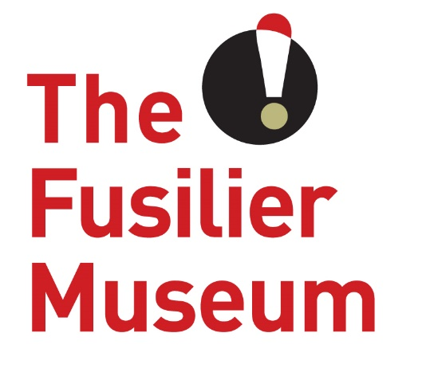

Community Development and Volunteer Coordinator
Volunteer Role Description
The Fusilier Museum & Learning Centre Bury

What is a Community Development and Volunteer Coordinator
The Community Development and Volunteer Coordinator will develop a Community Engagement Plan for the museum as well as deliver and develop a volunteer strategy. This will include the recruitment and retention of all volunteers as well as the day-to-day management of a volunteer programme.
What’s in it for you?
- The opportunity to work in an award-winning museum environment
- Lead an enthusiastic volunteer team in a beautiful building with local and historic significance
- To build a volunteer programme and identify volunteering needs across the business
- A sense of fulfilment knowing that you are helping to support a much-loved part of local and regimental history
What’s involved?
- To recruit and manage a team of volunteers across the business
- To develop and deliver training plans for each volunteer role in collaboration with appropriate colleagues.
- To engage with formal local community networks and groups to widen participation in the museum and strengthen relationships between the museum and the local community.
- To contribute to the marketing of volunteering and community initiatives to raise public awareness and increase participation.
- To evaluate activities and implement recommendations to the programme.
- Represent and promote the Museum to external organisations and at relevant meetings.
- To support wider activities at the Museum when appropriate.
This role will suit people who…
- Want to gain experience working in the museums and/ or volunteer sector
- Ability to inspire and motive volunteers
- Have excellent communication skills
- Strong organizational skills
- Are patient with an outgoing personality
- Have the ability to work on their own
- Lead a team
- Able to work flexible hours
- Good knowledge of the theory and practice of Community Development
- · Competency in a range of skills including the use of IT, expenses management and data collection
- Are willing to undergo a Disclosure and Barring check

Extra information
Time Commitment: Ideally 2- 3 days a week but would consider less time for the right person.
Reports To: Karan Lee, Trustee responsible for Volunteers
Training for the role:
- Customer care
- Working with young people and learning groups
- Safeguarding and dementia friendly training
About The Museum
The Fusilier Museum is home to the collections of the XX Lancashire Fusiliers and the Royal Regiment of Fusiliers. Together they record over 300 years of history and heritage of the people who served and continue to serve in the regiments.
As well as being an award-winning museum it is also a conference and events venue and regular location for school visits throughout the year. It also has an archive which assists people with family history enquiries about the Lancashire Fusiliers.
The museum is as much about the future as it is about the past. Building on an exploration of the past and the present, The Museum is a place for people to take part of a community. It is a place for people to share their hopes and visions of a better future, and to work together to create the community we want to live in.
The museum has a growing friendly team of volunteers who are at the very heart of everything we do. The volunteers share our passion to provide a unique, experience rich in heritage and culture. The contribution and dedication of our volunteers enables us to provide a sustainable museum that is available to everyone.
This role is purely voluntary, and this arrangement is not meant to be legally binding or an employment contract.

www.fusiliermuseum.com

